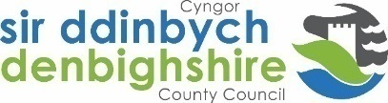
e
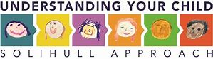

Ysgol Pentrecelyn invite you to sign up to a course……..
Understanding your child - popular online course
Free to all parents in Denbighshire Primary Schools – would normally cost £39
Contact your family link worker – Nia 07825531371
This is an enjoyable, well-established and trusted way of understanding more about your child. ‘Understanding your child’ is for mums, dads, grandparents and carers. Parents often say they feel calmer, more confident and have a better relationship with their child. The course was developed in the NHS together with frontline practitioners.
The course can be done on any PCs, iPads, laptop or smartphone, at a time and pace to suit family life and can even be listened to as well as read.
There are 11 modules each taking around 20 minutes with interactive activities, quizzes, video clips, practical handouts
Understanding your teenager’s brain also included.
The course covers
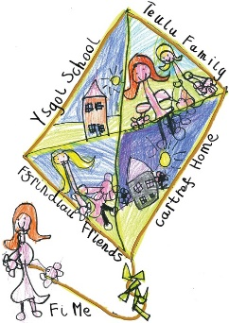
Responding to how your child is feeling
How your child develops
Different styles of parenting
How your child communicates
Understanding your child’s behaviour
Sleep, self-regulation and anger

