UAC yn annog plant i ddylunio cerdyn Nadolig amaethyddol er budd elusen
News 06 Medi 2021
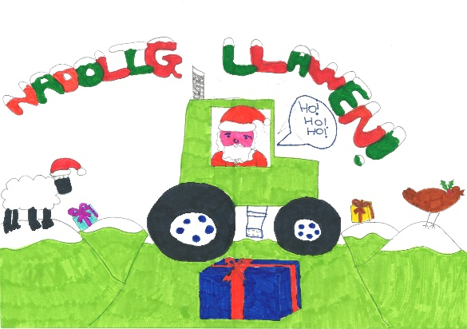Mae disgyblion ysgolion cynradd o bob rhan o Gymru yn cael eu gwahodd i gymryd rhan mewn cystadleuaeth i ddylunio cerdyn Nadolig ar y thema ffermio ar gyfer cystadleuaeth cardiau Nadolig UAC.
Mae UAC yn gofyn i blant rhwng pedair ac 11 oed i ddylunio golygfa amaethyddol Nadoligaidd ar gyfer ei chardiau Nadolig, a fydd yn cael eu gwerthu i godi arian ar gyfer elusen yr Undeb sef y DPJ Foundation.
Dywedodd Llywydd UAC Glyn Roberts: “Caiff y gystadleuaeth ei rannu’n ddau gategori - yr ymgeiswyr Cymraeg a’r ymgeiswyr Saesneg. Gall y plant ddefnyddio unrhyw gyfrwng i greu eu cardiau, megis creonau, pensiliau lliw, peniau blaen ffelt neu baent i dynnu’r llun, ac mae’n rhaid defnyddio dalen A4 o bapur a’i e-bostio atom ar ffurf jpeg.
“Yr unig amod yw bod yn rhaid iddo fod yn gerdyn Nadolig sy’n dangos golygfa amaethyddol. Mae’r gystadleuaeth wedi bod yn llwyddiant mawr yn y gorffennol a gobeithio, y gallwn sicrhau cefnogaeth ein hysgolion cynradd ar draws Cymru unwaith eto.”
Bydd enillydd pob categori yn derbyn tocyn anrheg gwerth £30 i’w hunain, pecyn o’r cardiau Nadolig yn dangos eu dyluniad, mynediad un diwrnod am ddim i Ffair Aeaf Frenhinol Cymru 2021 er mwyn derbyn eu gwobrau a siec gwerth £50 ar gyfer eu hysgol.
Y dyddiad cau ar gyfer ceisiadau yw dydd Gwener Hydref 29 2021.
Mae angen i bob cynnig gynnwys enw, oedran, rhif dosbarth, enw’r ysgol a chyfeiriad cartref y disgybl a’i e-bostio at ytir@fuw.org.uk

FUW encourages children to submit farming Christmas card design in aid of charity
News 06 September 2021
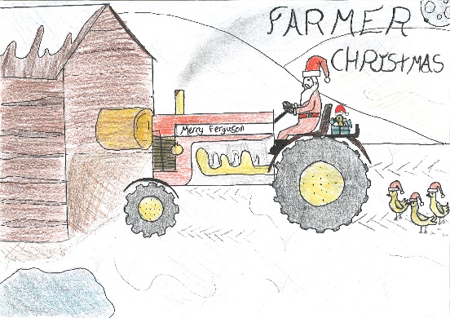Primary school pupils from all over Wales are being invited to enter a Christmas card design themed around farming for the FUW’s Christmas card competition.
The FUW is asking children aged from four to 11 to design a Christmas farming scene for its Christmas cards, which will be sold to raise money for the Union’s charity The DPJ Foundation.
FUW President Glyn Roberts said: “The competition will be split into Welsh language and English language categories. Children can use any media in their entries, such as crayons, coloured pencils, felt tipped pens or paint which must be completed on an A4 sheet of paper and emailed to us in jpeg format.
“The only stipulation is that it must be a Christmas card showing a farming scene. The competition has been a huge success in the past and we hope we can once again count on the support of our primary schools all over Wales.”
The winner of each category will receive a £30 gift voucher for themselves, a packet of the Christmas cards depicting their design, one day’s free admittance to the 2021 Royal Welsh Winter Fair to receive their prizes and a £50 cheque for their school.
The closing date for entries is Friday October 29 2021.
The pupil’s name, age, class number, school name and home address must be included on all entries, which should be e-mailed to ytir@fuw.org.uk

