Day | Time | Activity | Notes
Mercher  28/6/23 | 7:30yb  2:00yp  5:00yh  5:30yh  7:00yh | Cychwyn o Rhuthun/Start from Ruthin  Sain Ffagan  Cyrraedd y Gwersyll - Sesiwn groeso a phennu ystafelloedd  Arrive at the hostel – Welcome Session and rooms allocated  Swper/Super  Nofio / Swimming | Cofiwch pecynnau bwyd eich hunain!  Remember your packed lunch!  Cofiwch dillad nofio  Remember your Swimming Costumes and towel
Iau  29/6/23 | 8:30am  10:00 - 12:00yp  10:00 - 12:00yp  12:15pm  1:00 - 3:00yp  1:00 - 3:00yp  3:30yp  6:00yh  7:30pm | Brecwast/ Breakfast  Senedd /Welsjh Assembly  Stadiwm Beldroed G’dydd/ Football Stadium Cardiff  Cinio / Lunch  Senedd / Welsh Assembly  Stadiwm Beldroed G’dydd / Football Stadium Cardiff  Bowlio 10 /Ten Pin Bowling  Supper/Super  Noson ffilm yn y Gwersyll /Film night at the hostel | Grwp 1  Grwp 2  Canolfan yr Urdd yn trefnu pecyn bwyd/Urdd centre providing a packed lunch  Grwp 2  Grwp 1  Bydd angen cit ymarfer corff (sesiwn pel droed yn y stadiwm)  Pupils will need a PE kit for a football session at the ground.
Gwener  30/6/23 | 8:30yb  10:30yb  12:30yp  5:30yh | Brecwast / Breakfast  Pwll Mawr  Cinio (yn Pwll Mawr) / Lunch at the Big Pit  Cyrraedd Ruthun / Arrive back to Ruthin | Pacio fyny, gadael ystafelloedd a pigo fyny pecynnau bwyd  Packing up, leaving rooms and picking up the packed lunches.
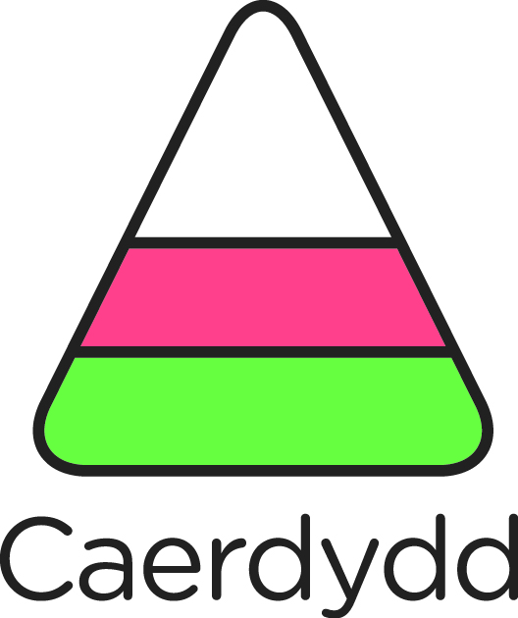
GWERSYLL YR URDD CAERDYDD
Clwstwr Ysgolion Dyffryn Clwyd
28 - 30 Mehefin (2023)
(103 Disgybl + 13 Staff)

