Ysgol Pentrecelyn

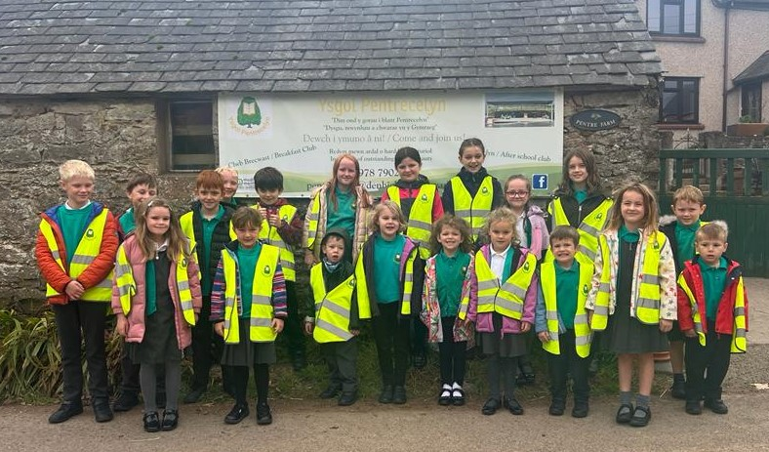

First of all …

“Dear new pupil,

On behalf of the School Cabinet we would like to welcome you to Ysgol Pentrecelyn. Your first day will probably feel quite strange, but there are plenty of people to look after you. The older pupils have been through the same experiences and our family ethos means we all help each other to be happy and safe at all times.”

… and for the Parents!
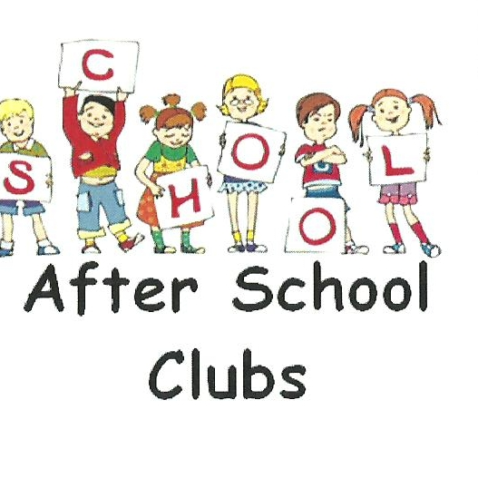
2022– 2023 School Prospectus

Breakfast Club
Open from 8:00

Cylch Ti a Fi
Wednesday
10-11:30
Neuadd yr Ysgol
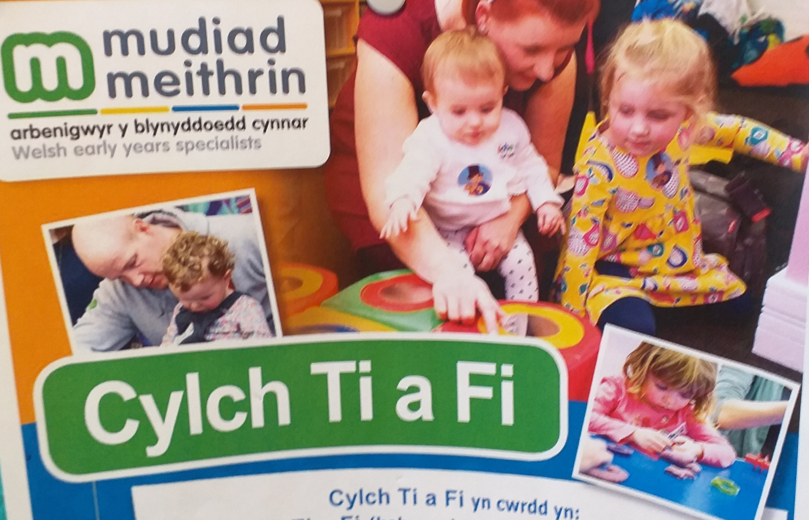

Clwb Celyn
After School Club
3:15 – 5:30

School
A school full of history since 1874
1

Welsh
A Welsh-Medium School in a supportive rural community
2

Beauty
In an area of Outstanding Natural Beauty
3
Thank you for considering Ysgol Pentrecelyn as a school for your child/ren.
“Ysgol hardd, fu’n hyrwyddo –talent
Plant i flaguro,
Dal mewn bri mae brethyn bro
A’r heniaith heb heneiddio.”

We are pleased to tell you about what we can offer our pupils, and assure you that having chosen Ysgol Pentrcelyn for your child we will do our utmost to ensure that they will receive the best start in life and will look back at their early education with fondness, happiness and pride!

Our priority is to provide a caring and secure environment for your child, with a wide range of learning experiences allowing them to grow into independent, responsible 21st Century citizens. We can only achieve this with close parental partnership and we aim to work with you in order to do so.

We will always listen to, support and share our school with you. Your child’s needs are central to our aims, our planning and development and we will do our very best to ensure the best for them!
2022 - 2023

“ Learn, enjoy and play in Welsh”
Choosing the right school for your child is vitally important. Parents want a good education for their child but they also want them to be happy and to feel safe and secure. At Ysgol Pentrecelyn we believe we can offer all these things. We pride ourselves on the broad, balanced and full education we provide and the high standards of teaching and learning are a credit to the hard work of both staff and pupils. Equally we are also proud of the atmosphere of friendliness and co – operation which is always evident.
We are fully confident that you will have made the right decision by choosing Ysgol Pentrecelyn.

Dim OND Y GorAu i Blant Pentrecelyn

Ysgol Pentrecelyn,

Pentrecelyn, Rhuthun LL15 2HG

Tel: 01978 790288

EBost: pentrecelyn@sirddinbych.gov.uk

DYSgu, Mwynhau a chwarae yn gymraeg

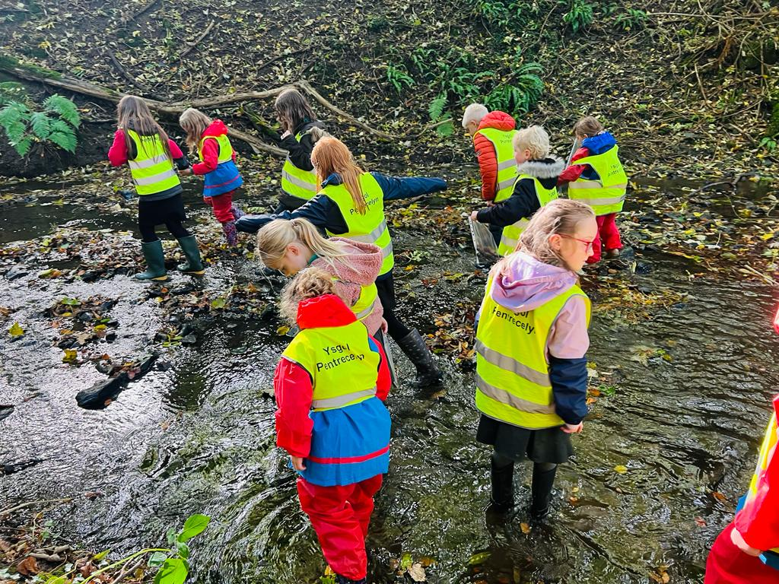

Only the best for Pentrecelyn Pupils
ADMISSION PROCEDURES TO YSGOL PENTRECELYN AND LIAISON WITH OTHER SCHOOLS.

Admissions Policy

The Local Education Authority is the admission authority for every pupil. Children will be accepted to the Early Years on a part time basis at the start of the term following their 3rd birthday and full time in the September following their 4th birthday.
We also accept children to our Rising 3s provision in the term following their 3rd birthday.

In the Autumn term the Denbighshire Local Authority’s Admission Panel meet to consider the application forms for the school’s September intake. Parents will then be informed of the decision of the panel.
Where admissions are incidental i.e. at other times during the school year, parents and their children are invited to visit the school to familiarise themselves with the building and to meet members of staff and children.
Prior to entry to the school, parents/guardians are asked to complete a medical form, an out of school visits form, permission/consent slip and to sign an agreement that the school and home will endeavour, in partnership, to give your child the best possible education. This is the ‘Home-School Agreement’. A Pupil Data form from Denbighshire LA is also included in the pack. These must all be completed before your child can be admitted to the school.
2022 - 2023
The permission/consent slip is very important and must be returned as soon as possible. Also, of particular importance is the need for us to know a telephone number in case of emergency.
The medical form tells us of any medical or physical problems we need to know - such as allergies, etc. and is most important. There are many activities that take place in school which involve food tasting, etc. We also need to know of any changes in situation which may have a bearing on your child’s school life – in writing please.
Pupils are transferred to secondary school in the September following their eleventh birthday. We begin the fun and exciting process of familiarising the children with high school in Year 4. Afternoons and days out at the High School are arranged for the pupils. Most of our children transfer to Ysgol Brynhyfryd. Arrangements are made for the staff and Year 6 pupils to visit Ysgol Brynhyfryd to facilitate this process and High School staff visit Ysgol Pentrecelyn beforehand.
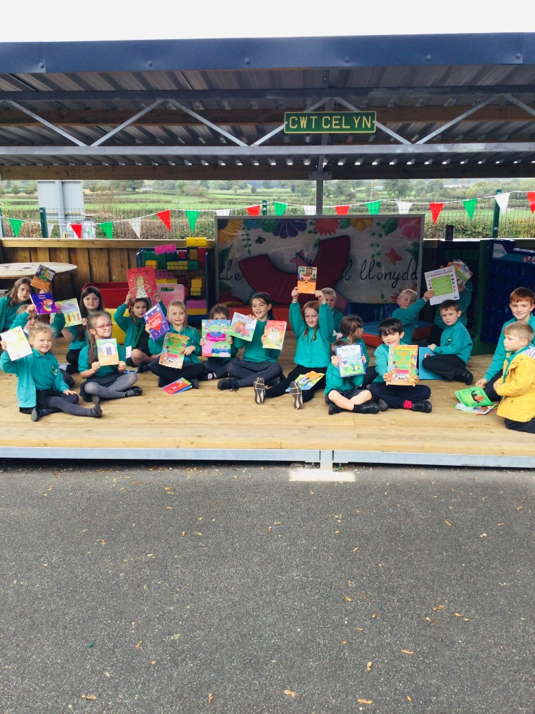
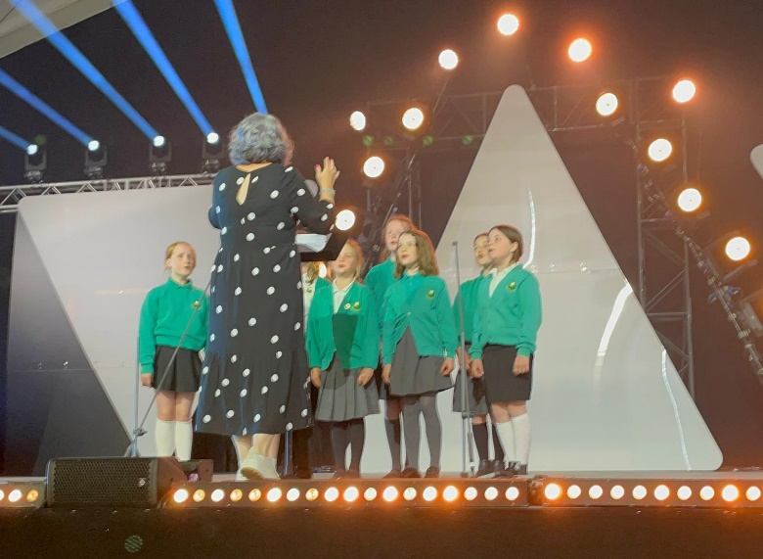

The Use of the Welsh Language

Welsh is the language of the teaching in all areas of the Early Years and Foundation Phase. When children start school in the Early Years with little or no knowledge of the Welsh language they are submerged in the language sensitively. In Key Stage 2 all core subjects, except English, are taught mainly through the medium of Welsh, although as the children reach Yr 6, there is more of a balance between the languages in written work. The foundation subjects are also mainly taught through the medium of Welsh.

If a child is registered into school in Key Stage 2 with no previous knowledge of the Welsh language, there is an opportunity for them to attend a Catch Up course organised by the Local Education Authority (as long as they reach a basic level of Literacy and Numeracy). Every pupil will be looked at individually, depending on the age of the child, to assess the degree of teaching through the medium of English during a transition period.
We encourage the children to use the Welsh language as the means of communicating in the classroom, playtime and outside the school environment. Every effort is made to ensure that a child receives a full education whatever their ability in the Welsh language. Our aim is to ensure they become fluently bilingual.

Site, Buildings and Grounds

The school was opened in 1874 and has been modernized since then. The classrooms are attractively laid out and the school's excellent facilities include:
- A modern hall with apparatus for Drama, Music and Movement, Gymnastics and school assemblies.
- A very attractive school garden.
- Outside facilities comprise of a large playground along with a large playing field and additional gardens.

However, at present the building is unsuitable for pupils with a physical disability. A feasibility plan has been created outlining the necessary modification. The school would work alongside the LEA to implement this plan should the need arise.

SCHOOL CURRICULUM
We are now moving forward with the new Successful Futures Curriculum with its 4 Main Purposes, 3 pillars of; Numeracy, Literacy and Digital Competency and also the 6 Areas of Learning.
The school seeks to give the curriculum breadth, relevance and balance. It also seeks to differentiate the learning experiences it provides to meet the needs of all the pupils. To do this a variety of teaching strategies are used ranging from whole class lessons and group sessions through to individual investigations. Further skill development takes place through carefully structured ‘thematic’ days to learning. The curriculum is enriched through educational visits, visitors to the school, etc. to give relevance to the skills and concepts that the children acquire. We use a mixed-ability and age approach to teaching and learning. This is based upon thorough research into class structuring and it’s impact on learning.

The organisation of the school is the responsibility of the Headteacher in consultation with the Governors. From Sept 2022 the school will be organised as follows:
Nursery, Reception, Year 1 and 2 will be taught in one Foundation Phase class during the day.
Year 3, 4, 5 and 6 will be in one Key Stage 2 class.
Enquiries about the curriculum should be directed to the Headteacher.
RELIGIOUS EDUCATION AND COLLECTIVE WORSHIP
The school seeks to promote positive attitudes within the children such as integrity, moral values, considerate behaviour and the relationship between belief and action in life. These are developed principally within Religious Education lessons and school assemblies but may often be addressed as an aspect of work in other areas of the school curriculum – particularly Personal Social Health Education.
They are most positively encouraged by the pastoral care which forms an integral part of the day-to-day running of the school.
Parents/Guardians wishing to withdraw their children from Religious Education are asked to write to the Headteacher and to inform the teachers involved. In these cases, alternative work must normally be provided by parents.
There is daily collective worship in the form of school and class services, which are broadly of a Christian nature. Parents/Guardians wishing to withdraw their children from collective worship are asked to write to the Headteacher. Pupils who are withdrawn from collective worship will be supervised by a member of staff.

SAFEGUARDING
Ysgol Pentrecelyn is committed to safeguarding and promoting of welfare of children and expects all staff and volunteers to share this commitment. Staff work hard to maintain an environment where children feel safe and secure. The curriculum is designed to ensure opportunities for children to develop the skills they need to recognise and stay safe from abuse including while accessing the internet. Children know they can approach any of the adults in the school if they are worried and they will receive a consistent supportive approach.
In recognising our responsibilities for Safeguarding and Child Protection, as a school we:
- Ensure all staff, including volunteers who have unsupervised access to children, have been appropriately checked for their suitability through DBS procedures.
- Aim to raise awareness of child protection issues and equip children with the skills needed to keep them safe.
- Develop and implement procedures for identifying and reporting cases, or suspected cases of abuse.
- Support children who have been abused in accordance with his\her Child Protection Plan.
- Establish a safe and nurturing environment free from discrimination or bullying where children can learn and develop happily.
Named Child Protection Co-ordinator for the School : Mr Andrew Evans
Second Nominated CP Co-ordinator for the School : Mrs Jan Wilson-Jones
Child Protection Governor : Mrs Sarah Wynne
Safeguarding Co-ordinator for Denbighshire Education Services : Wayne Wheatley
SEX AND RELATIONSHIP EDUCATION
The school aims to provide a broad and balanced curriculum which promotes the development of all learners and gives them the best possible basis for their future growth and development.
Sex and Relationships Education(SRE) is taught in a cross curricular approach across several of the Foundation Phase areas of learning and not as a separate subject. We believe that an age-appropriate, well planned SRE programme, which starts in the Foundation Phase and continues throughout Key Stage 2 will equip learners with the skills and knowledge to make safe and responsible choices as they grow up.

External Government agencies will, on occasion, visit the school and offer age appropriate lessons and activities to help support the pupils’ development.

OUR PUPILS…
All of our pupils are special and over their time in school many may receive additional help at one time or another.
We provide a high quality education for all our pupils, including those with Additional Learning Needs and those who display More Able and Talented characteristics. If a pupil displays difficulties in certain areas of the curriculum, the school, in accordance with the Special Education Code of Practice, has a comprehensive policy. Pupils will initially receive additional support in class from teachers. Pupils who display difficulties in Literacy or Numeracy will be targeted through focused activities.
DISABILITY AND ACCESSABILITY
We have a policy for accessibility which outlines the school’s approach to ensuring that pupils and adults with disabilities have equal access to the schools facilities, curriculum, day to day activities and learning experiences.
The school is committed to ensuring equal treatment of all our staff, pupils and any others involved in the school community. The school maintains a policy of non-discrimination and equal opportunities for all and has a ‘Strategic Equality Plan’ and ‘Equality Policy’. These documents provide us with a framework for integrating disability equality into all aspects of school life. The documents are available at the school on request.
All disabled pupils are encouraged and supported to take part in all school activities including physical education, outdoor pursuits and educational visits.
In the case of a pupil with disabilities seeking admission to the school, the LA would be contacted for advice from the Special Educational Needs Department so that the most appropriate provision may be planned for and provided. Disabled pupils will not be treated less favourably in the admissions process.
If any parent or carer has additional needs relating to disability and/or language, cultural issues with which they require assistance at a particular school event, please contact the school to arrange the assistance requested.
HOMEWORK/Home-Learning
The school considers homework and home-learning to be a way of extending and reinforcing work done in the classroom. It should be remembered that any homework given will only be a continuation of work begun in class and they need to complete this in order to cover all aspects of work in certain subjects. There is no strict weekly homework policy.
Children are provided with Reading Diaries and Logs. The diaries can also be used to aid in the communication between home and school. We ask that you encourage and support children with their reading. Take every opportunity to work with your children. Get them involved in day to day maths and language activities such as helping price up the shopping, finding the best deal for fuel when filling the car, reading and discussing the offers sent by companies to tempt you into buying their products. These help place all the things they learn at school into context.
ASSESSMENT
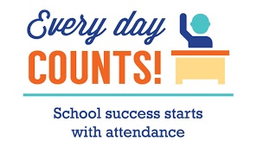
There is continuous assessment of all the pupils' progress throughout the year. In addition, the children are given standardised tests in Welsh, English and Mathematics. These tests indicate the progress pupils have made and also help identify those children who require additional support. Each child has a brief verbal progress report each term and a full written report at the end of the academic year. We use assessments and tests as a small part of the whole picture.
Your child is more than a test score. Our teachers know the children and understand the best way to support and develop their achievement and attainment whilst at school.
Parents/Guardians may make an appointment to see a member of staff regarding their child's progress by contacting the school office or making an appointment with them at the school gate.
ATTENDANCE
Attending school regularly is very important - it is very difficult to try to make up for lost time later on. We therefore always have to insist upon a note, visit or phone call to inform us as to the reason a child is away on the first day of absence.
We are also now required by law to state on the register whether the absence is authorised or unauthorised. The percentage of unauthorised absences have to be shown on your child's annual report.
Punctuality
Punctuality is an important life-skill for the pupils to learn. Being late can also be very wasteful of children's school time - just 10 minutes lateness each day is the equivalent of over 6 full days in a year!
School gates open at 8:45am for pupils not attending

Breakfast Club.
In the event of unusual situations, such as frequent or regular days off, unexplained absences or lengthy absences, the Educational Social Worker (ESW) will be contacted to make further enquiries by phone calls, letters or home visits.

Holidays
Strictly speaking, holidays during term time are not permitted. Parents do not have an automatic right to withdraw pupils from school for a holiday and, in law, have to apply for permission in advance. Application forms are available from the secretary, and should be submitted at least 2 weeks prior to the holiday.
Instructions to schools are, however, that at the headteacher’s discretion, they can consider time off to a maximum of 10 days an academic year in exceptional circumstances e.g those families serving in the armed forces. Holidays are not extra to any days taken off due to illness. It all counts as one.
Please note that Staff Training dates may vary between schools!
PARENT PAY
Ysgol Pentrecelyn is part of the Parent Pay system of online payments. We do not handle cash.
Each child’s parent will be given their own, secure and individual log in details and will be able to keep a track of all bill payments using their online account. Each child will have a separate account under their parents control and name.
The accounts can transfer from primary to secondary school BUT all outstanding balances must be paid in full before your child leaves Ysgol Pentrecelyn.
Payments for school dinners, trips, uniform, fruit and music lessons are done using Parent Pay.
Please speak to our school secretary Glenda Jones for further details.
SCHOOL DINNERS - £2.90
Ysgol Pentrecelyn is currently following the Welsh Government initiative for Healthy Eating. During break times, only fruit are to be consumed during this time. Children are also encouraged to drink water throughout the day.
Meals are cooked and served in the school. We do ask you to pay on the first day of each week and do not allow arrears to build up. After two weeks of arrears we have been instructed by the LEA that further meals must not be supplied until the arrears are paid in full. We must also report the arrears to the finance officers in the County who judge whether or not fines etc. must be imposed.
Due to new legislation, all dinner arrears are taken directly from our school budget. This impacts on the provision for your child as we would have to make cuts elsewhere in the budget to accommodate the dinner money arrears taken from our school account.
If eligible, parents/guardians may apply for free school meals for their child. We strongly advise parents to apply for this support. Discretion is used at all times. Application forms may be obtained either from the school or Council Revenues and Benefits Assessment Service Section in Denbighshire. Please take advantage of this offer if you are entitled.

SPORTING AIMS AND PROVISION
At Ysgol Pentrecelyn we participate in all sorts of Urdd and local Sports tournaments.
Swimming lessons are a statutory requirement for all pupils. The lessons are held at Ruthin Swimming Pool for pupils from the reception class up to Year 6. Swimming takes place in the Spring term. The lessons are free although we need to raise a charge for the transport to and from the pool.
We endeavour to;
- promote a healthy lifestyle (which hopefully will be continued into adulthood);
- foster self-esteem;
- encourage co-operation, tolerance and fair play;
- promote self expression through the physical;
- promote safe practice in physical activities.
Children at Ysgol Pentrecelyn are encouraged to enjoy physical education and also to develop confidence and skill. We aim to provide a safe and secure environment in which all children, irrespective of age, ability, disability, race or gender, can successfully participate so helping to develop the whole child physically, intellectually and socially.
Infant/Foundation Phase children are asked to leave their PE kit in school and they will be sent home periodically for washing etc.
The emphasis at our school is 'Sport for All'. Physical Education, including swimming, is a statutory requirement. All pupils must take part. Without a letter, Doctor’s note or communication from parents, children will be expected to take part in the lessons.
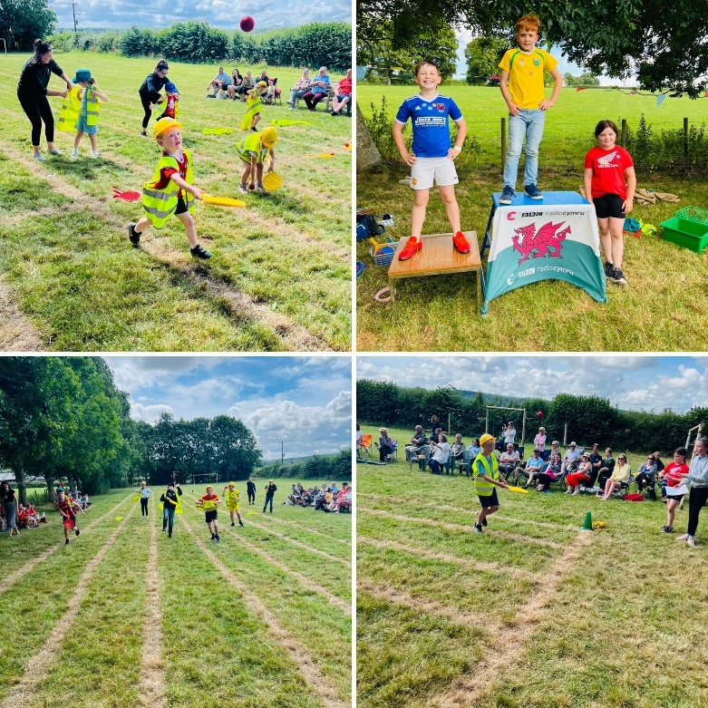
School Uniform

The school has an official uniform and pupils are encouraged to wear it:
- jade green sweatshirt with the offical school logo
- grey/dark skirt or trousers
- t-shirt, shorts or jogging pants and trainers for PE lessons

It is possible to buy school uniform at R&R Embroidery, Lôn Parcwr, Ruthin (01824 704483 – sales@ randrembroidery.co.uk – www. randrembroidery.co.uk).

All clothing should be clearly marked with your child’s name.

ILLNESS OR ACCIDENT
When a pupil is taken ill during the school day, and a home/emergency telephone number is available, the parents/guardians will be contacted and asked to come to collect their son/daughter. When no home/emergency telephone number is available the When a pupil is taken ill during the school day, and a home / emergency telephone number is available the school we will contact them and ask them to come and collect their son / daughter. When there is no home / emergency number available the school will endeavor to contact a neighbor or relative that you have listed as an additional contact..
If the school fails to find a suitable and safe place to leave the pupil, then he/she will be kept at school until 3.15pm unless it appears clear that more urgent action needs to be taken.
In the case, for example, of an accident at school – even if parents have been contacted, the pupil will, if necessary, be transported to hospital by ambulance or other means, with a member of staff. The parents once contacted are expected to collect the child from the hospital.
It is clearly very important that the school is provided with the place of work and telephone number of parents/guardians as well as an emergency contact person.
If your child has ANY medical or other condition which might have a bearing upon his/her life in school, or which might affect others, then the school must be informed. This might be, for example, the need to wear glasses or a condition such as asthma. This must be done in writing – to the office as well as to the class teacher. If a condition requires immediate medical treatment, such as extreme allergic reaction to nuts or stings, then we need to know precisely what measures to take. Obviously an emergency contact routine is essential in these cases. In such situations, training of staff will have to have been undertaken beforehand.
Frequently with those children suffering from asthma, they are able to take their own medication by inhaler. These must be left, clearly labelled with your child’s name, in the school office for safe keeping and clear instructions left with them as to when and how often they ought to be used. They may be needed by pupils, for example, during swimming or other sports activities, in which case they can be collected from the office and returned later.
If a child requires medication then it ought to be given either before and after the school day, or by a parent who should come in to school for that purpose.
We can, however, supervise pupils who can self-administer medicine. A form available from the school office must be completed giving full details of the medication and all medication must be brought to school by an adult. All medication must be clearly labelled with the child’s name.
MEDICAL
From time to time, the School Medical Officer or Nurse will visit the school to examine children. You will be notified of any such visit and you will be welcome to attend school during such examinations. The School Nurse sometimes visits the school, the main reason for her presence being for screening purposes.
Head Lice
It is estimated that at any one moment 1 in 10 of all primary age children in Britain suffer from head lice! If you discover that your child has head lice, we must ask that you treat it as soon as possible according to established methods - before your child returns to school.
Toilets

Although we encourage the pupils to use the toilets during playtimes in order to reduce disruption to lessons, they are free to leave the classrooms whenever the need arises. The toilets in the main building are mainly used by the Foundation Phase children, and by all the children during playtimes. The toilets in the house are used by KS2 pupils. Every toilet is cleaned daily by the Caretaker.

Ffrindiau Pentrecelyn - CYMDEITHAS RHIENI FFFRINDIAU AC ATHRAWON
PARENT TEACHER and FRIENDS ASSOCIATION
All parents/guardians are automatically members of the association. Meetings are normally held at school and the programme is varied, having included talks on educational matters, concerts and social functions. Fund-raising events are organised and the association has already made substantial contributions to the school.
The very existence of this association indicates a healthy partnership between the parents, teachers and the community. We do ask for your full support in all our activities - they are for the benefit of your child.
We urge all parents to take an active role in the association either on the committee or as an occasional helper at any of the events.
Many fundraising events are held throughout the year including pupil discos, Christmas Fair, cake days and the Summer Sports Fair. All funds raised are used to provide vital equipment for the school and pupils.
We as a school are incredibly grateful to all the members of Ffrindiau Pentrecelyn and hope you will support them, the pupils and us as well.
COMPLAINTS, CONCERNS AND COMPLIMENTS
Considering a complaint and finding a solution which enables us to move forwards together to improve the provision for all pupils can be a very positive experience.
Our Open Door policy enables you make an appointment to raise any areas of concern with your child’s class teacher, or if the issue persists, with the head teacher and we will be happy to work with you to resolve any issues reasonably and as soon as is possible.
We find that many complaints can be dealt with quickly and effectively through informal discussion with the teachers or headteacher. This is the first step, and Governors will expect that the complaints process will have been followed before a formal complaint is made.
Should there be no satisfactory resolution, you have the right to make a formal, written complaint to a panel of the Governing body.
GENERAL INFORMATION
School day
8:45yb School Gates open
9:00yb School day starts
10:30yb - 10:50yb Break time
12:00yp - 1:00yp Lunch
2:00yp - 2:10yp Break time
3:15yp School day finishes

Fruit
The children are encouraged to eat fruit on a daily basis.
Property
Please ensure that you clearly mark your child/rens’ uniform and other property with their names.
Milk
Children in the Foundation Phase class are given milk every day. This is a free service offered by the LA. If you’re child has any intolerance to milk please ensure you fill this in on the information sheet and tell the class teacher.
URDD
All pupils are encouraged to become members of the Urdd. The process is quick and easy and is completed online by parents. The school then has a record of members to enter into all the events that take place. If you have any difficulty you are more than welcome to come into school for advice.

DATES
Autumn | 2022 - 2023
Term start | 01/09/2022
Staff training day | 1/09/2022  2/09/2022
Half Term Close | 28/10/2022
Half Term Open | 07/11/2022
End of Term | 23/12/2022
Spring | 2022 - 2023
Term start | 09/01/2023
Staff training day | 09/01/2023
Half Term Close | 17/02/2023
Half Term Open | 27/02/2023
End of Term | 31/03/2023
Summer | 2022 - 2023
Term start | 17/04/2023
May Bank Holiday | 01/05/2023
Coronation Bank Holiday | 08/05/2023
Half Term Close | 26/05/2023
Half Term Open | 05/06/2023
Staff training day | 20/07/2023
End of Term | 20/07/2023

Conclusion
This prospectus relates to the school year 2022-2023. The details are correct at the time of publication, but there may be some changes affecting the particulars before the start of or during the academic year.
We look forward to working in partnership with you to make your child’s time with us happy and fruitful in every way.
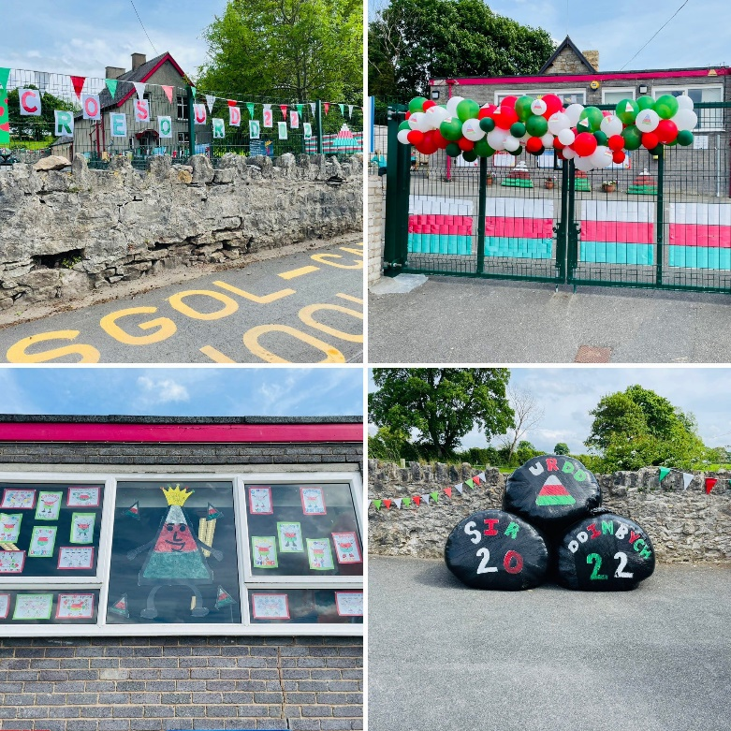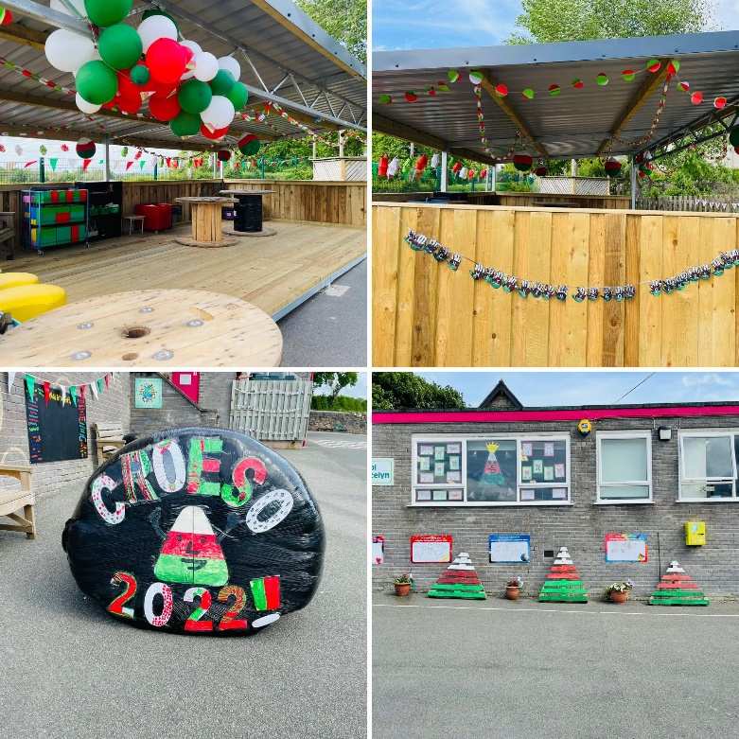
Autumn 2022

DIM OND Y GorAu i Blant Pentrecelyn

Ysgol Pentrecelyn,

Pentrecelyn, Rhuthun LL15 2HG

Tel: 01978 790288

EBost: pentrecelyn@sirddinbych.gov.uk

Dysgu, Mwynhau a chwarae yn gymraeg

